Reliability Testing

Reliability concerns the extent to which a measurement of a phenomenon provides stable and consist result. Reliability is also concerned with repeatability. For example, a scale or test is said to be reliable if repeat measurement made by it under constant conditions will give the same result.
Testing for reliability is important as it refers to the consistency across the parts of a measuring instrument. A scale is said to have high internal consistency reliability if the items of a scale “hang together” and measure the same construct.
In split-half reliability, a test for a single knowledge area is split into two parts and then both parts given to one group of students at the same time. The scores from both parts of the test are correlated. A reliable test will have high correlation, indicating that a student would perform equally well (or as poorly) on both halves of the test.
Split-half testing is a measure of internal consistency — how well the test components contribute to the construct that’s being measured. It is most commonly used for multiple choice tests you can theoretically use it for any type of test — even tests with essay questions.
For an exploratory or pilot study, it is suggested that reliability should be equal to or above 0.60. It is suggested to have a four cut-off points for reliability, which includes excellent reliability (0.90 and above), high reliability (0.70-0.90), moderate reliability (0.50-0.70) and low reliability (0.50 and below).

Steps:
- Administer the test to a large group students (ideally, over about 30).
- Randomly divide the test questions into two parts. For example, separate even questions from odd questions.
- Score each half of the test for each student.
- Find the correlation coefficient for the two halves. See: Find Pearson’s Correlation Coefficient for steps.
Example question: Find the value of the correlation coefficient from the following table:
SUBJECT AGE X GLUCOSE LEVEL Y
1 43 99
2 21 65
3 25 79
4 42 75
5 57 87
6 59 81
Step 1: Make a chart. Use the given data, and add three more columns: xy, x2, and y2.
SUBJECT AGE X GLUCOSE LEVEL Y XY X2 Y2
1 43 99
2 21 65
3 25 79
4 42 75
5 57 87
6 59 81
Step 2: Multiply x and y together to fill the xy column. For example, row 1 would be 43 × 99 = 4,257.
SUBJECT AGE X GLUCOSE LEVEL Y XY X2 Y2
1 43 99 4257
2 21 65 1365
3 25 79 1975
4 42 75 3150
5 57 87 4959
6 59 81 4779
Step 3: Take the square of the numbers in the x column, and put the result in the x2 column.
SUBJECT AGE X GLUCOSE LEVEL Y XY X2 Y2
1 43 99 4257 1849
2 21 65 1365 441
3 25 79 1975 625
4 42 75 3150 1764
5 57 87 4959 3249
6 59 81 4779 3481
Step 4: Take the square of the numbers in the y column, and put the result in the y2 column.
SUBJECT AGE X GLUCOSE LEVEL Y XY X2 Y2
1 43 99 4257 1849 9801
2 21 65 1365 441 4225
3 25 79 1975 625 6241
4 42 75 3150 1764 5625
5 57 87 4959 3249 7569
6 59 81 4779 3481 6561
Step 5: Add up all of the numbers in the columns and put the result at the bottom of the column. The Greek letter sigma (Σ) is a short way of saying “sum of” or summation.
SUBJECT AGE X GLUCOSE LEVEL Y XY X2 Y2
1 43 99 4257 1849 9801
2 21 65 1365 441 4225
3 25 79 1975 625 6241
4 42 75 3150 1764 5625
5 57 87 4959 3249 7569
6 59 81 4779 3481 6561
Σ 247 486 20485 11409 40022
Step 6: Use the following correlation coefficient formula.
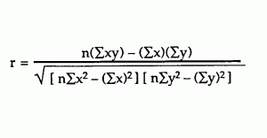
The answer is: 2868 / 5413.27 = 0.529809
From our table:
Σx = 247
Σy = 486
Σxy = 20,485
Σx2 = 11,409
Σy2 = 40,022
n is the sample size, in our case = 6
The correlation coefficient =
6(20,485) – (247 × 486) / [√[[6(11,409) – (2472)] × [6(40,022) – 4862]]]
= 0.5298
The range of the correlation coefficient is from -1 to 1. Our result is 0.5298 or 52.98%, which means the variables have a moderate positive correlation.
References:
McLeod, S. What is Reliability? Retrieved April 8, 2019 from: https://www.simplypsychology.org/reliability.html

Another explanation:

Split-Half Basic Concepts
One way to test the reliability of a test is to repeat the test. This is not always possible. Another approach, which is applicable to questionnaires, is to divide the test into even and odd questions and compare the results.

Example 1: 12 students take a test with 50 questions. For each student, the total score is recorded along with the sum of the scores for the even questions and the sum of the scores for the odd question as shown in Figure 1. Determine whether the test is reliable by using the split-half methodology.

Split-half methodology

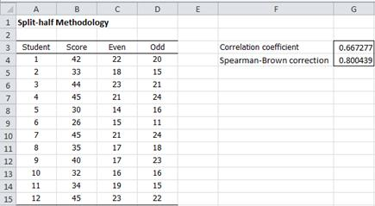
Figure 1 – Split-half methodology for Example 1

The statistical test consists of looking at the correlation coefficient (cell G3 of Figure 1). If it is high then the questionnaire is considered to be reliable.

r = CORREL(C4:C15,D4:D15) = 0.667277

See Basic Concepts of Correlation for more information about the correlation coefficient r.

One problem with the split-half reliability coefficient is that since only half the number of items is used the reliability coefficient is reduced. To get a better estimate of the reliability of the full test, we apply the Spearman-Brown correction, namely:

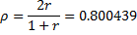

This result shows that the test is quite reliable.

This version of the Spearman-Brown correction works properly when the two halves have equal length. If not, then we can use the following formula (provided r ≠ ±1):

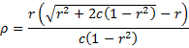

where c = 2p(1–p) where p = the proportion of the test due to the first half. Note that if the two halves are equal, then c = 2(.5)(.5) = .5, and so

Note that if a test has an odd number of items 2n + 1, then n/(2n+1), and so

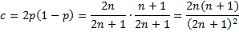

For example, if we obtain a correlation coefficient of .6 on a 2-3 split of a 7 question test, then c = 2(.4)(.6) = .48 and so

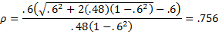

which is slightly higher than the result that would be obtained if we assumed an even number of questions, i.e.

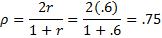

Note that SB_CORRECTION(.6,5,2) = .756 using the Real Statistics function described next.

Real Statistics Functions: The Real Statistics Resource Pack contains the following functions:

SB_CORRECTION(r, n, m) = Spearman-Brown correction when the split-half correlation based on an m vs. n-m split is r. If n is omitted, then it is assumed that there is a 50-50 split. If n is present, but m is omitted, then it is assumed that m = n/2.

SB_SPLIT(R1, s) = split-half coefficient (after Spearman-Brown correction) for data in R1 based on the split described by the string s. String s consists of 0’s and 1’s where each character in the string corresponds to one column in R1 (thus the length of s must be equal to the number of columns in R1)

SPLIT_HALF(R1, R2) = split-half coefficient (after Spearman-Brown correction) for data in ranges R1 and R2; assumes a 50-50 split.

SPLITHALF(R1, type) = split-half measure for the scores in the first half of the items in R1 vs. the second half of the items if type = 0 and the odd items in R1 vs. the even items if type = 1.

The SPLIT_HALF function ignores any empty cells and cells with non-numeric values. This is no so for the SPLITHALF function.

For Example 1, SPLIT_HALF(C4:C15, D4:D15) = .800439.

Example 2: Calculate the split-half coefficient of the ten-question questionnaire using a Likert scale (1 to 7) given to 15 people whose results are shown in Figure 2.

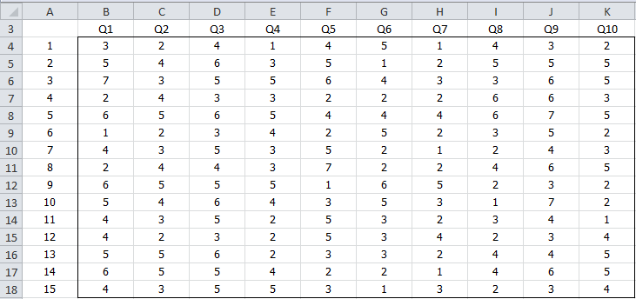

Figure 2 – Data for Example 2

We first split the questions into the two halves: Q1-Q5 and Q6-Q10, as shown in Figure 3.

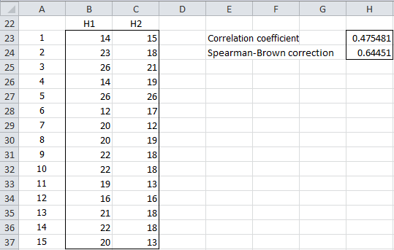

Figure 3 – Split-half coefficient (Q1-Q5 v. Q6-Q10)

E.g. the formula in cell B23 is =SUM(B4:F4) and the formula in cell C23 is =SUM(G4:K4). The coefficient 0.64451 (cell H24) can be calculated as in Example 1. Alternatively, the coefficient can be calculated by the worksheet formula =SPLIT_HALF(B23:B37,C23:C37) or =SPLITHALF(B4:K18,0).

We can also split the questionnaire into odd and even questions, as shown in Figure 4.

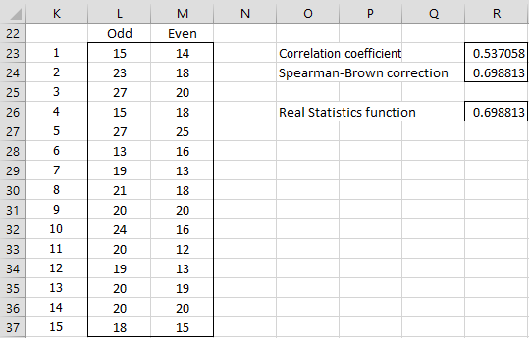

Figure 4 – Split-half coefficient (odd v. even)

E.g. the formula in cell L23 is =B4+D4+F4+H4+J4 and the formula in cell M23 is =C4+E4+G4+I4+K4. The coefficient 0.698813 (cell R24) can be calculated as in Example 1. Alternatively, the coefficient can be calculated by the Real Statistics formula =SPLIT_HALF(L23:L37,M23:M37) or =SPLITHALF(B4:K18,1).

References:
Mustafa, S. H., Charles, makweta, J., Zelchenko, P., Ezra, I., Benedetto, Rocchi, B., Emmanuel, Lt, Eman, Khan, M., Cyrus, Qaiser, R., Yadav, A., Manglani, K., Etuk, E., Mutum, S., Jasdeep, A.Ukoha, U., … Lamiss. (n.d.). Sadam Hamisi Mustafa. Real Statistics Using Excel. Retrieved March 17, 2023, from https://real-statistics.com/reliability/internal-consistency-reliability/split-half-methodology/split-half-basic-concepts/

